DATE: 16.11.2018
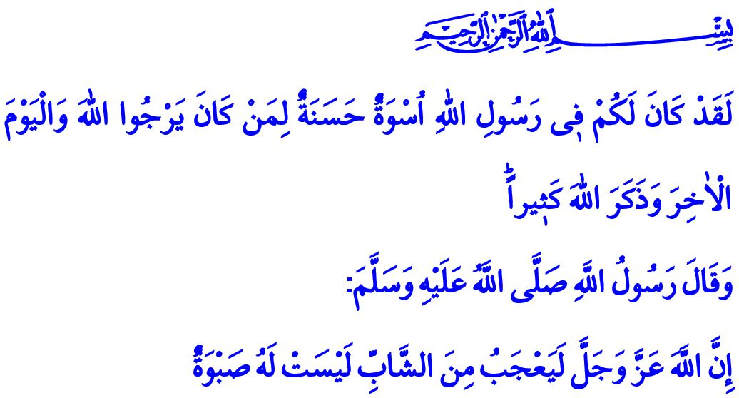
MAWLID AL-NABI
(THE BIRTH OF PROPHET MUHAMMAD)
Esteemed Believers!
We will attain the anniversary of the Mawlid al-Nabi, which is the day our Beloved Prophet (saw) honored the world, on Monday night next week. All praise be to our Lord (swt) for bestowing us the bliss of being the ummah of Muhammad. May peace, greetings and blessings be upon our Prophet, the cause of mercy and guidance to humankind, to his family and companions.
Honorable Muslims!
Allah the Almighty introduces our Prophet (saw) as: “O Prophet, indeed We have sent you as a witness and a bringer of good tidings and a warner. And one who invites to Allah, by His permission, and an illuminating lamp.” Our Prophet is a witness to the right and the verity, he is a bringer of good tidings on the path of goodness, and a warner against the falsehood. He is the one who conveyed the Holy Qur’an to the ummah, explained and taught it by living himself accordingly. He is the one who invited humanity to serenity, peace, and justice. The Messenger of Allah (saw) is also the one who led the ummah in every phase of his life, directed to the right way and enlightened our path in this world of tests by being a guide to us.
Valued Believers!
For those who believe in Allah and seek His countenance, and who want to be august and happy in both worlds, Muhammad Mustafa (saw) is “uswatun hasanah”, the most beautiful example. It is stated by our Lord (swt) as follows: “There has certainly been for you in the Messenger of Allah an excellent pattern for anyone whose hope is in Allah and the Last Day and [who] remembers Allah often.”
The Companions (ra), who were educated by him observing such a distinguished example, have become the symbols of faith and justice, knowledge and wisdom, courage and mercy. Each member of the Islamic society that he built was dignified by leaving behind the darkness of the jahiliyya (age of ignorance), and they delivered the revelation’s message of peace and trust wherever they went.
Dear Muslims!
The Messenger of Allah (saw) was a decent young before his prophethood as well. Those who first recognized Muhammad, who was known as “Muhammad al-Amin (Muhammad the Reliable) in his society, were also the young people of the time. His honest, virtuous, conscientious and just persona was the greatest assurance for the youth. Our Prophet (saw), who taught his young companions to live with perfect faith, righteous deeds, and good morality, raised them as role models that would shine on the horizon of humanity.
Esteemed Believers!
Our Prophet (saw) is a unique example for us also in understanding the young people and preparing them for the future. He (saw) always trusted young people, gave them responsibility, paid attention their ideas, and corrected their mistakes without hurting them. When the Prophet (saw) sent Mus’ab to Madinah as a teacher, Mu’adh to Yemen as a judge, appointed Usama to be commander of the army, and left Ali (ra), before setting out for the Hijrah with the carry-on food that Asma gave him, in his own bed to buy time, they were all young.
Young Brothers/Sisters!
The Messenger of Allah (saw) stated, “Allah loves the young one, who is not subject to his/her desire, who does not deviate from what is right.”. Today, just like the young companions, you are going through the most fertile years of your life capital. Even though there are many deceptive and diverting fake attractions around you that may drag you away from the truth, you should always rely on the power of faith, the motivation of worship, and the value of morality. You need to expend your youth energy in the efforts that are appropriate for the contentment of your Lord, and you need to take the Prophet (saw) as your guide and role model. For it is you who are going to strive to help goodness dominate the world and find a cure for the bleeding wounds of humanity! For it is you who are the burgeoning hope of this noble homeland, this great nation, and the ummah of the Prophet Muhammad (saw)!
Valued Believers!
The birthday of our Beloved Prophet, the 12th night of the month of Rabi al-Awwal in the Hijri calendar, falls on November 19 this year. The week of that night will be celebrated as “Mawlid al-Nabi Week”. The Presidency of Religious Affairs has determined the theme of the week for this year as “The Prophet Muhammad and the Youth” We will take this opportunity to get to know our Prophet (saw) more closely, understand him better, and particularly take as example his communication with the young people, and look for solutions in his Sunnah to address the problems of our young people. May the Week of Mawlid al-Nabi bring auspiciousness to our noble nation and all the Islamic world. Amin!

Ahzab, 33/45,46.
Ahzab, 33/21.
Ahmad ibn Hanbal, IV, 151. General Directorate of Religious Services

